1. Create a Console application call LeagueTable.
2. Create a class called **Team** that has properties to hold the team name, number of wins, number of draws, number of losses, number of games and the points. All of these properties are read only. The team name is set in the Constructor that takes in one parameter.
3. Create **Team** objects for five teams such as the following:

Team SligoRovers = new Team("Sligo Rovers");

Team FinnHarps = new Team("Finn Harps");

Team GalwayUnited = new Team("Galway United");

Team DerryCity = new Team("Derry City");

Team Dundalk = new Team("Dundalk");

1. Create an array of type Team to hold all the Team objects and add the Team objects created to the array.
2. Using a loop print out all the details of the **Team** objects in a table such as below:

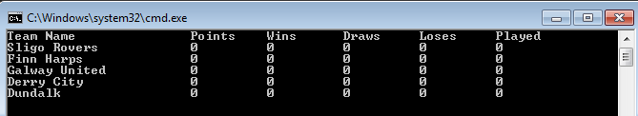

1. Create an enum called **Result** in the **Team**  class that has 3 elements {Win, Draw, Lose}. (We have not covered this, some research needed).
2. Create a method called AddResult in the Team class that takes in one parameter of type Result and depending on the result update the read only properties.
3. For each Team object call the AddResult method and supply a Result such as below:

SligoRovers.AddResult(Team.Result.Win);

FinnHarps.AddResult(Team.Result.Lose);

FinnHarps.AddResult(Team.Result.Draw);

GalwayUnited.AddResult(Team.Result.Win);

Dundalk.AddResult(Team.Result.Lose);

1. Using a loop print out all the details of the Team objects in a table such as below:



1. Implement the **IComparable** interface to allow the **Team** objects be compared based on points.
2. Sort the array and then reverse it so the team with the highest points is listed first.



1. Add a new auto implemented property called ManagerName. Create a new Constructor that takes in a team name and a manager name. Link the constructors using the this keyword (We have not covered this, some research needed). If the Team object is created with only a team name the managers name is added as “AnOther”